IBM NALAIYA THIRAN

0

**PROJECT REPORT**

**K.L.N COLLEGE OF ENGINEERING, POTTAPALAYAM**

(An Autonomous institution, affiliated to Anna university, Chennai)



**Problem statement :** Smart Fashion Recommender System

**Team ID :** PNT2022TMID11603

**Team Leader :**  Shara Banu M S

**Team members :**  Sheshavardhini M

Susmitha V S

Vaishnavi R

**Faculty mentor :** T.T. Mathangi

**Evaluator :** A.Selvaraj

**Industry mentor :** Krishna chaitnaya

**INDEX**

|  |  |  |
| --- | --- | --- |
| **SNo** | **Topic** | **Page number** |
| **1** | **Introduction** | 2 |
| 1.1 | Project overview | 2 |
| 1.2 | Purpose | 2 |
| **2** | **Literature survey** | 4 |
| 2.1 | Existing problem | 3 |
| 2.2 | References | 3 |
| 2.3 | Problem statement definition | 5 |
| **3** | **Ideation and proposed solution** | 6 |
| 3.1 | Empathy map canvas | 6 |
| 3.2 | Ideation and Brainstorming | 7 |
| 3.3 | Proposed solution | 8 |
| 3.4 | Problem solution fit | 10 |
| **4** | **Requirement analysis** | 10 |
| 4.1 | Functional requirements | 11 |
| 4.2 | Non-functional requirements | 12 |
| **5** | **Project design** | 13 |
| 5.1 | Data flow diagrams | 13 |
| 5.2 | Solution and technical architecture | 14 |
| 5.3 | User stories | 17 |
| **6** | **Project planning and scheduling** | 18 |
| 6.1 | Sprint planning and estimation | 18 |
| 6.2 | Sprint delivery schedule | 18 |
| **7** | **Coding and solutioning** | 20 |
| 7.1 | Sprint-1 | 20 |
| 7.2 | Sprint-2 | 29 |
| 7.3 | Sprint-3 | 36 |
| 7.4 | Sprint-4 | 37 |
| **8** | **Testing** | 35 |
| 8.1 | Test case | 35 |
| 8.2 | User acceptance testing | 35 |
| **9** | **Result** | 38 |
| 9.1 | Performance metrics | 38 |
| **10** | **Advantages and Disadvantages** | 39 |
| **11** | **Conclusion** | 40 |
| **12** | **Future scope** | 41 |
| **13** | **Appendix** | 43 |

# Introduction:

Fashion is perceived as a meaningful way of self-expressing that people use for different purposes. It seems to be an integral part of every person in modern societies, from everyday life to exceptional events and occasions. Fashionable products are highly demanded, and consequently, fashion is perceived as a desirable and profitable industry. Although this massive demand for fashion products provides an excellent opportunity for companies to invest in fashion-related sectors, it also faces different challenges in answering their customer needs.

In recent years, the textile and fashion industries have witnessed an enormous amount of growth in fast fashion. On e-commerce platforms, where numerous choices are available, an efficient recommendation system is required to sort, order, and efficiently convey relevant product content or information to users. Smart Fashion Recommender Application have attracted a huge amount of attention from fast fashion retailers as they provide a personalized shopping experience to consumers. Smart Fashion Recommender Application have been introduced to address these needs.

* 1. **Project overview:**

The Fashion industry is one of the larger industries around the world. One of the things that has remained constant throughout human civilization is humans covering their bodies with a piece of cloth. Initially, this cloth was worn as protection from the harsh climates of those ages. Later on, as we humans learned to fend for ourselves from the unforgiving climates, the cloth started to serve a different purpose. Fashion these days showcases the individuality of the person. There are many things that can be said about a person based on their fashion sense.

## 1.2 PURPOSE

There is currently no existing system that is capable of recommending clothes based on the occasion. Different occasions call for different clothing. Moreover, a lot of fashion is based on the color combinations of outfits. A person with no or little fashion sense will have a hard time to decide on clothes that leave a lasting impression. The proposed Fashion Recommendation System is intended to be used by individual users in order to store images of the clothes that they own in what is called a digital wardrobe and also to get recommendations by the system on what clothes to wear for a given occasion. The main aim of the project is to recommend the most appropriate clothes for a given occasion based on the clothes existing in the user’s wardrobe to relieve the user of the burden of making decisions about what clothing to wear. Such a system should be capable of helping someone who has no fashion sense to wear clothes that leave a good impression on others. The system should be such that it is easily accessible and easy to take advantage of the various features that it provides. One of the features should be the ability to store images that the user uploads into a wardrobe. A wardrobe is a very useful entity that the user can use to view and manage the images of clothes that they have uploaded. This feature can also be used by the recommendation algorithm to recommend the clothes. Another feature is the classification of the type and color of the clothing that is uploaded by the user. The system should be capable of handling the 4 basic clothing types: Shirt ,T-Shirt, Pants and Shoes.

**2 Literature survey**

In a literary survey, we analyse critically, and concisely earlier research and literature related to a particular research problem and utilize them for their own research purposes. It helps us in understanding the significance of new research and its connections to earlier work.

* 1. **Existing problem**

In existing system only simple web application and their rating has been implemented in existing system, An ecommerce product recommendation engine is a piece of technology that displays recommended products to shoppers throughout your store. It uses machine learning to get smarter and show increasingly relevant products to shoppers based on their interests and previous browsing behavior.

.

* 1. **References**
     1. GloablInfoResearch: Global Fast Fashion Apparel Market 2021 by Key Countries, Companies, Type and Application. GloablInfoResearch, HongKong, 2021.
     2. Hou, M., Wu, L., Chen, E., Li, Z., Zheng, V. W., & Liu, Q.:Explainable fashion recommendation: A semantic attribute region guided approach. In Proceedings of the 28th Twenty-Eighth International Joint Conference on Artificial Intelligence, 2019; pp. 4681- 4688.
     3. Hidayati, S. C., Hsu, C. C., Chang, Y. T., Hua, K. L., Fu, J., & Cheng, W. H.: What Dress Fits Me Best? Fashion Recommendation on the Clothing Style for Personal Body Shape. In Proceedings of the 26th ACM International Conference on Multimedia (MM '18). Association for Computing Machinery, New York, NY, USA, 2018; pp. 438-446.
     4. Wang, H., Wang, N., & Yeung, D. Y.: Collaborative Deep Learning for Recommender Systems. In Proceedings of the 21th CM SIGKDD International Conference on Knowledge Discovery and Data Mining, New York, 2015; pp. 1235- 1244.
  2. **Problem Statement Definition**

The personal information collected by recommenders raises the risk of unwanted exposure of that information. Also, malicious users can bias or sabotage the recommendations that are provided to other users.In recent years, the textile and fashion industries have witnessed an enormous amount of growth in fast fashion. On e-commerce platforms, where numerous choices are available, an efficient recommendation system is required to sort, order, and efficiently convey relevant product content or information to users.

* The problem of the work is to design static web applications deployments with customer deployment
* Lack of interaction between application and user
* User need to navigate across multiple pages to choose right product
* Confusion in choosing product
* Lack of sales
* Complex User Interface.
* Lack of proper guidance

1. **IDEATION & PROPOSED SOLUTION**
   1. **Empathy Map Canvas**

An empathy map is a simple, easy-to-digest visual that captures knowledge about a user’s behaviours and attitudes.

It is a useful tool to helps teams better understand their users.Creating an effective solution requires understanding the true problem and the person who is experiencing it. The exercise of creating the map helps participants consider things from the user’s perspective along with his or her goals and challenges.

**EMPATHY MAP OF SMART FASHION RECOMMENDER SYSTEM**

**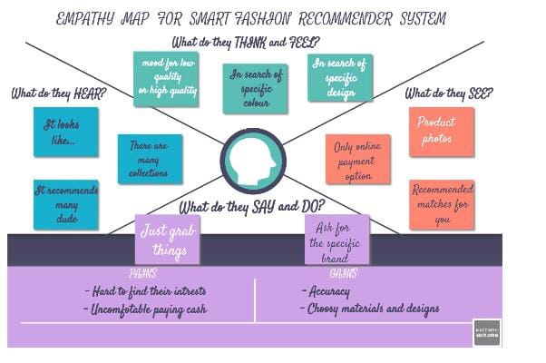**

* 1. **Ideation & Brainstorming**

**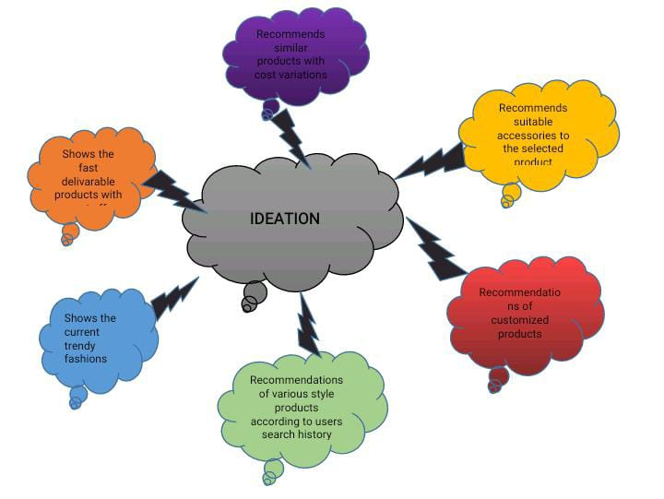**

* 1. **Proposed Solution**

|  |  |  |
| --- | --- | --- |
| **S.No.** | **Parameter** | **Description** |
|  | **Problem Statement (Problem to be solved)** | Online apparel shopping has been growing at a surprising speed in recent years.It is hard to know quickly and accurately what the user wants. This phenomenon leads to an extremely low utilization of information, also known as the information overload problem. keywords are used to retrieve images, but such methods require a lot of annotations on the image data, which will lead to serious problems such as inconsistent, inaccurate, and incomplete descriptions, and a huge amount of work.  One of the main drawbacks of online shopping is the lack of such service. Virtual try-on and fashion synthesis systems are the solutions to this problem, preventing customers from buying unsuitable and unexpected items, making sure to provide the customers with an enjoyable experience. Moreover, they can decrease the refunding rate of online stores. That is why a review is necessary of this critical subject. |
|  | **Idea / Solution description** | To solve this problem, Content Based Information Retrieval (CBIR) has gradually become a research hotspot. CBIR retrieves picture objects based entirely on the content. The content of an image needs to be represented by features that represent its uniqueness. Basically, any picture object can be represented by its specific shapes, colors, and textures. These visual characteristics of the image are used as input conditions for the query system, and a result the system will recommended nearest images and data set. This model can use deep learning approach to extract various attributes from images with clothes to learn the user’s clothing style and preferences. These attributes are provided to the correspondence model to retrieve the contiguous related images for recommendation.  The primary focus is on two categories of AI fashion applications: 1) Fashion virtual try-on and 2) Fashion synthesis. |
|  | **Novelty / Uniqueness** | **The uniqueness of our project is to recommend:**  Accessories to the selected dresses.  Products with cost variation.  Similar product with short dispatch durations. |
| **4.** | **Social Impact / Customer Satisfaction** | The increasing popularity of online fashion and online retail platforms is having a visible impact on the shopping experience of billions of customers, making millions of products available in online catalogs thus eliminating the need for physical visits to various stores and for waiting in long queues or trying on clothes in dressing rooms by providing personalized and affordable deliveries. This in turn has created novel challenges for platform providers, within which proper understanding of fashion choices of shoppers plays a crucial role. Shoppers tend to feel overwhelmed by the sheer choice of the assortment and brands, not being able to receive effective suggestions matching their style preferences as well as not being able to spot the right size and fit during the shopping experience. As a result, recommender systems are gaining momentum by mining.  The satisfactions is achieved when a customer get the exact product with reasonable cost.  The impact gets lower when the site shows off the product with all features anf failed to delivar the exact one as shown and when the quality gets decreased. |
| **5.** | **Business Model (Revenue Model)** | The model should be able to scan across all 280,000+ product images and automatically generate a group of recommended products that are customized to what the user has viewed/bought.  Speed is of the essence in an eCommerce firm. The group of recommended products should be generated within 2ms to meet the “real-time” requirements of the pipeline.  The model should be able to adapt to new trendy products and new users. |
| **6.** | **Scalability of the Solution** | The application should be flexible so that it gets updated with new features and recent trendy products automatically as per users style of selection. |

* 1. 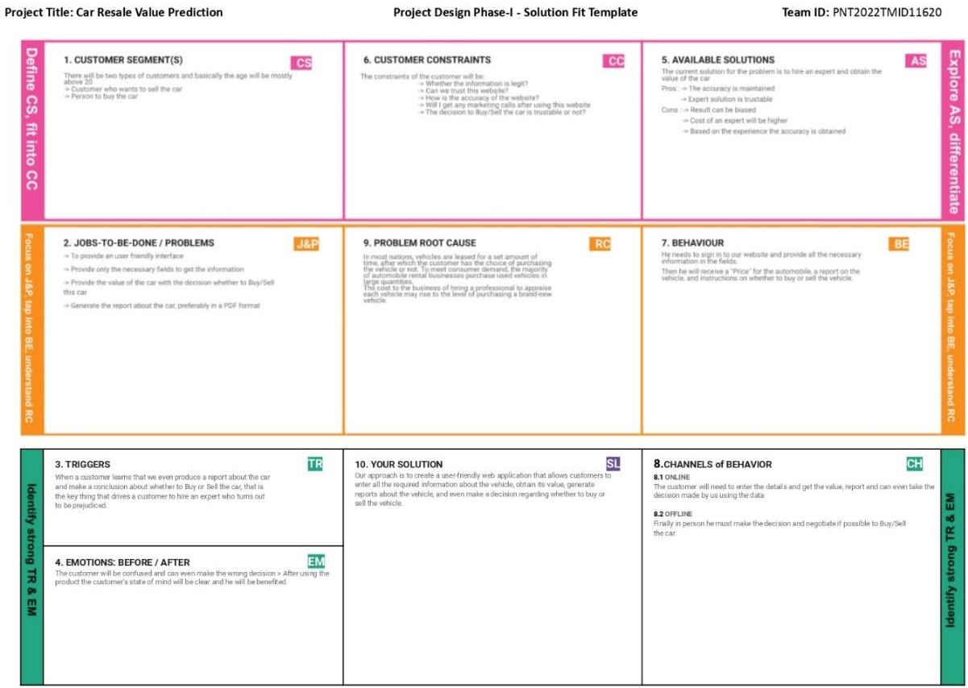**Problem Solution fit**

1. **REQUIREMENT ANALYSIS**
   1. **Functional requirement**

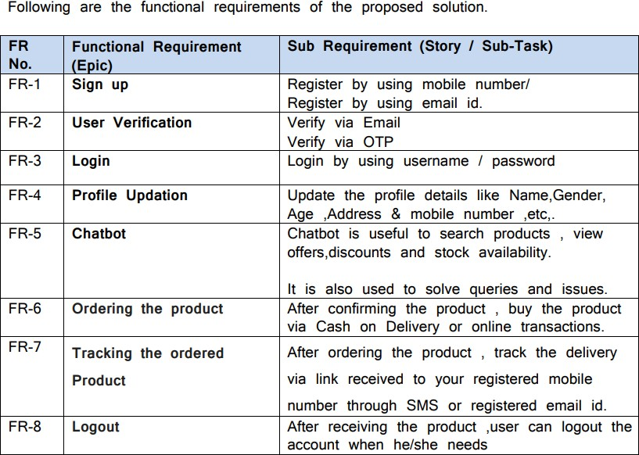**Non-Functional requirements**

**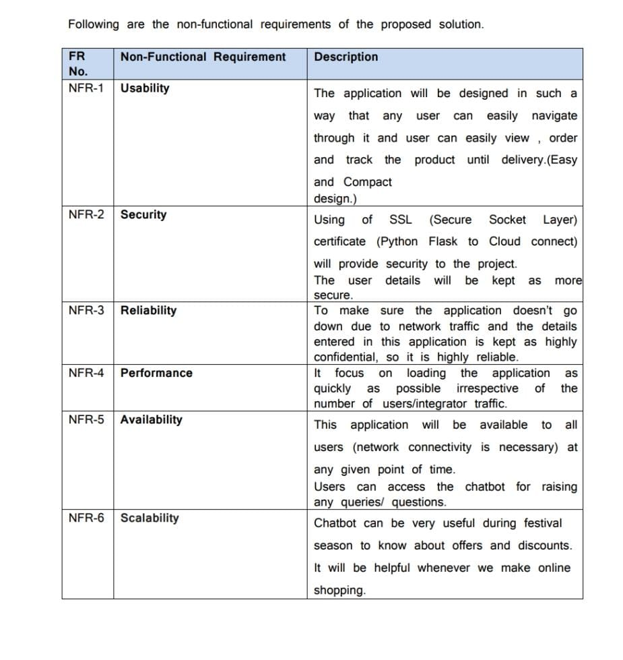**

# PROJECT DESIGN

* 1. **Data Flow Diagrams**

A Data Flow Diagram (DFD) is a traditional visual representation of the information flows within a system. A neat and clear DFD can depict the right amount of the system requirement graphically. It shows how data enters and leaves the system, what changes the information, and where data is stored.

**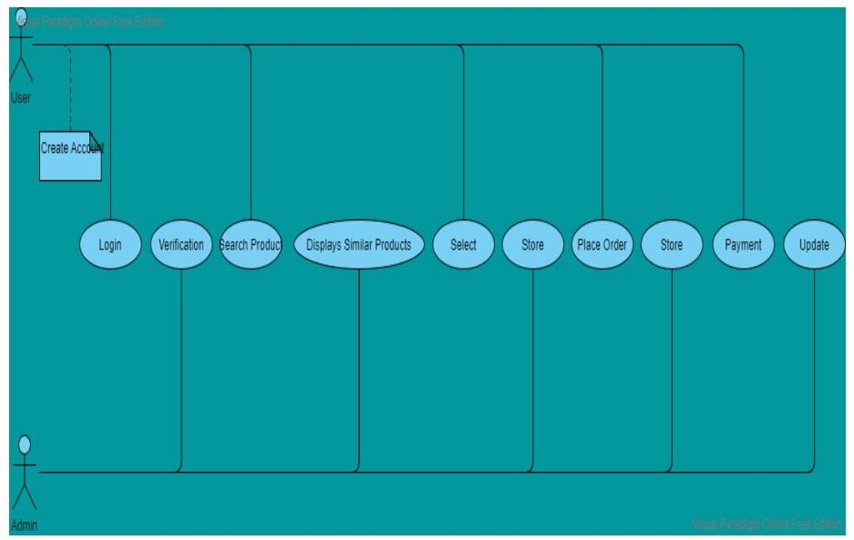**

## Solution & Technical Architecture

Solution architecture is a complex process – with many sub-processes – that bridges the gap between business problems and technology solutions. Its goals are to:

* Find the best tech solution to solve existing business problems.
* Describe the structure, characteristics, behavior, and other aspects of the software to project stakeholders.
* Define features, development phases, and solution requirements.
* Provide specifications according to which the solution is defined, managed, and delivered.

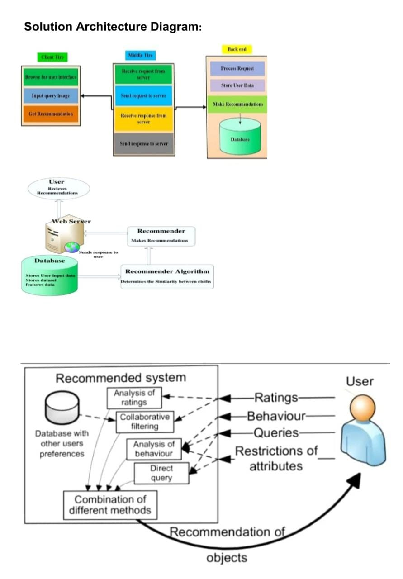

**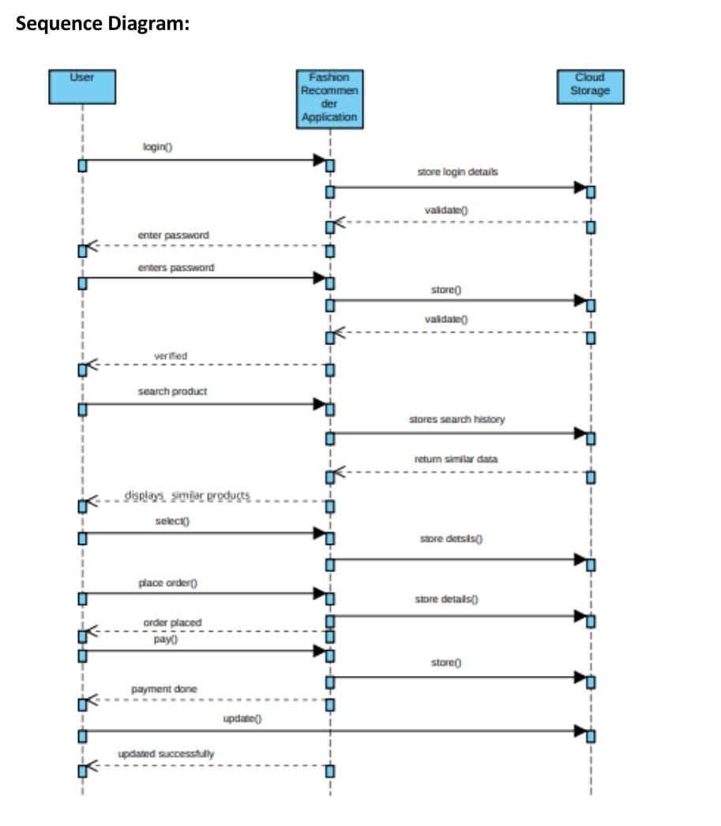**

**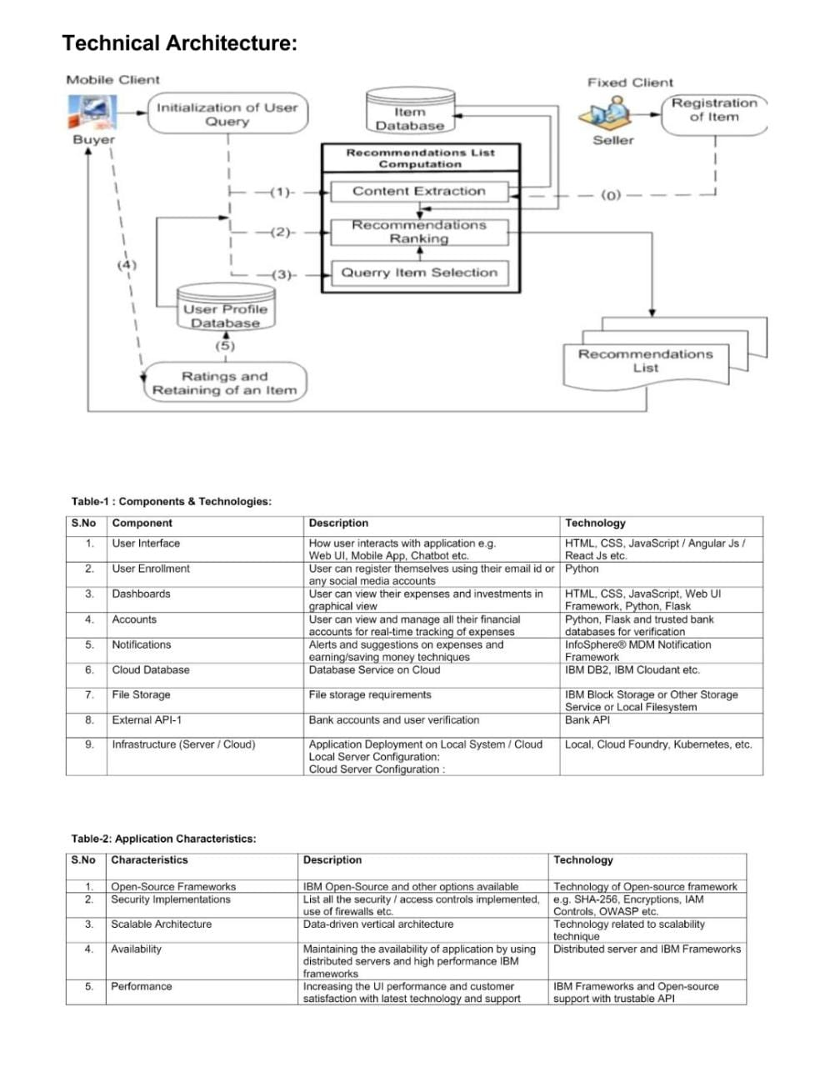**

**4.4user stories**

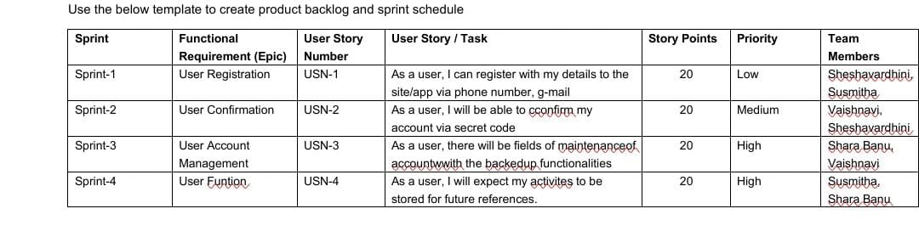

1. **PROJECT PLANNING & SCHEDULING**
   1. **Sprint Planning & Estimation**

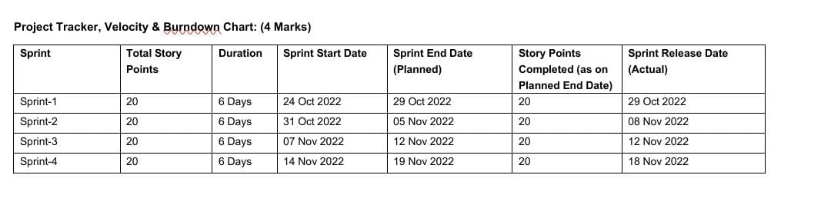

**Velocity:**

Imagine we have a 10-day sprint duration, and the velocity of the team is 20 (points per sprint). Let’s calculate the team’s average velocity (AV) per iteration unit (story points per day)



Sprint 1: 1 user story x 20 story points = 20

Sprint 2: 1 user story x 20 story points = 20

Sprint 3: 1 user story x 20 story points = 20

Sprint 4: 1 user story x 20 story points = 20

**Total = 80**

**Average sprint velocity is 80/4 = 20**

**Burndown Chart:**

**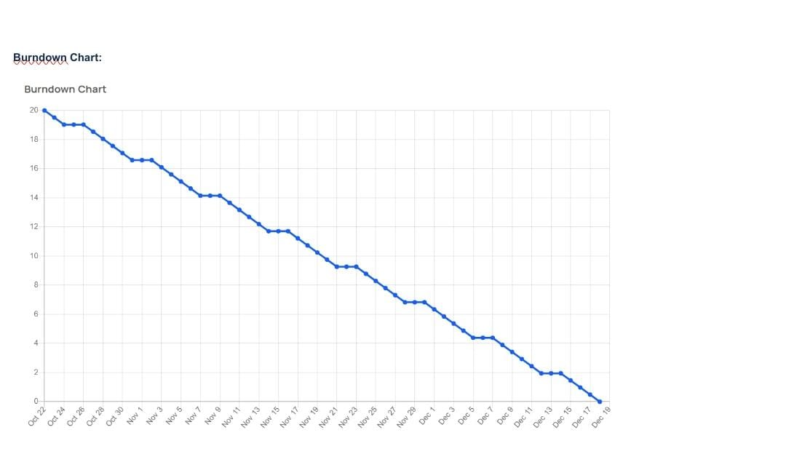**

**7CODING & SOLUTIONING**

**HOMEPAGE.HTML**

<html>

<head>

<title> FASHION FREAK </title>

</head>

<style>

\*{ margin: 0;

padding: 0;

font-family: "Times New Roman", Times, serif;

}

.main{

width: 100%;

background: linear-gradient(to top,rgba(0,0,0,0.5),rgba(0,0,0,0.5)50%); background-position: center;

background-size: cover; height: 100%;

font-family: "Times New Roman", Times, serif;

}

.navbar{

width: 100%; height: 75px; margin: auto;

}

.icon{

width: 200px; float: left; height: 70px;

}

.logo{

color:#FFFFFF; font-size: 35px;

padding-left: 20px; float: left;

padding-top: 10px;

}

.menu{

width: 400px; float: left; height: 70px;

}

ul{

float: left; display: flex;

justify-content: center; align-items: center;

}

ul li{

list-style: none; margin-left: 62px; margin-top: 27px; font-size: 15px;

}

ul li a{

text-decoration: none; color: #FFFFFF;

font-weight: bold; transition: 0.4s ease-in-out;

}

ul li a:hover{

color: rgb(98, 246, 152);

}

.search{

width: 330px; float: left;

margin-left: 270px;

}

.srch{

width: 200px; height: 40px;

background: transparent;

border: 1px solid rgb(98, 246, 152); margin-top: 13px;

color: #FFFFFF; border-right: none; font-size: 16px; float: left; padding: 10px;

border-bottom-left-radius: 5px; border-top-left-radius: 5px;

}

.btn{

width: 100px; height: 40px;

background:rgb(98, 246, 152) ;

border: 2px solid rgb(98, 246, 152); margin-top: 13px;

color: #FFFFFF; font-size: 15px;

border-bottom-right-radius: 5px; border-bottom-right-radius: 5px;

}

.btn:focus{ outline: none;

}

.srch:focus{ outline: none;

}

.content{

width: 1200px; height: auto; margin: auto; color: #800080; position: relative;

}

.content.par{

padding-left: 20px; padding-bottom: 25px;

letter-spacing: 1.2px; line-height: 30px;

}

.content h1{

font-size: 50px; padding-left: 20px; margin-top: 9%; letter-spacing: 2px;

}

.content .cn{ width: 160px; height: 40px;

background: rgb(98, 246, 152); border: none;

margin-bottom: 10px; margin-left: 20px; font-size: 18px; border-radius: 10px; cursor: pointer; transition: .4s ease;

}

.content .cn a{

text-decoration: none; color: #FBE7A1; transition: .3s ease;

}

.cn:hover{

background-color: #FBE7A1;

}

.content span{ color:rgb(98, 246, 152); font-size: 60px;

}

.form{

width: 250px; height: 380px;

background: linear-gradient(to top,hsla(89, 43%, 51%, 0.3)); position: absolute;

top: -20px; left: 870px;

border-radius: 10px; padding: 25px;

}

.form h2{ width: 220px;

text-align: center; color:rgb(98, 246, 152); font-size: 22px;

border-radius: 10px; margin: 2px; padding: 8px;

}

.form input{ width: 240px; height: 35px;

background: rgba(0, 255, 0, 0.5);

}

.form input{ width: 240px; height: 35px;

background: rgba(0, 255, 0, 0.5);

border-bottom: 1px solid rgb(98, 246, 152); border-top: none;

border-right: none; border-left: none; color: #fff;

font-size: 15px; letter-spacing: 1px; margin-top: 30px;

}

.form input:focus{ outline: none;

}

::placeholder{ color: #fff;

}

.btnn{

width: 240px; height: 40px;

background: rgb(98, 246, 152); border: none;

margin-top: 30px; font-size: 18px; border-radius: 10px; cursor: pointer; color: #fff; transition: 0.4s ease;

}

.btnn:hover{ background: #fff;

color: rgb(98, 246, 152);

}

.btnn a{

text-decoration: none; color: #000;

font-weight: bold;

}

.form .link{

font-size: 17px; padding-top: 20px; text-align: center;

}

.form .link a{

text-decoration: none; color: rgb(98, 246, 152);

}

.liw{

padding-top: 15px; padding-bottom: 10px; text-align: center;

}

</style>

<body>

<div class="main">

<div class="navbar">

<div class="icon">

<h2 class="logo">FASHIONZZ</h2>

</div>

<div class="menu">

<ul>

<li><a href="#">HOME</a></li>

<li><a href="#">ABOUT</a></li>

</ul>

</div>

<div class="search">

<input class="srch" type="search" name="" placeholder="TYPE TO SEARCH">

<a href="#"><button class="btn">SEARCH</button></a>

</div>

<img src="C:\Users\HP\Downloads\fashion-banner-people-cartoon-characters-flat- vector-illustration-isolated-fashion-banner-people-cartoon-characters-190292392.jpg">

</div>

</div>

</body>

</html>

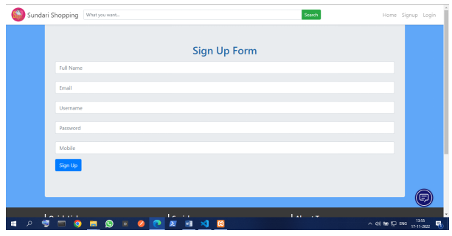

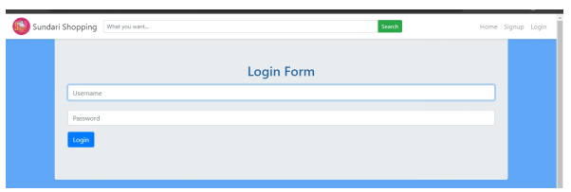

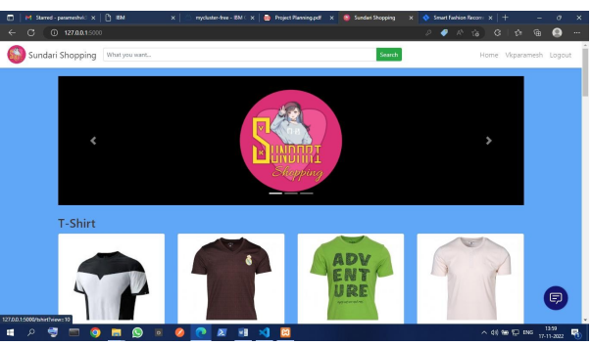

ss

## FEATURE 2:

**FINALHOME.HTML:**

<html>

<head>

<meta name="viewpoint" content="width=device-width, initial-scale=1.0">

<title>FASHION FREAK</title>

<link rel="stylesheet" href="https://storagedemo-madzh.s3.jp-tok.cloud-object- storage.appdomain.cloud/MadmukFinalhomecss.css">

</head>

<body>

<nav>

<a class="logo" href="MadFinalhome.html"><h2>FASHIONZZ HOME</h2></a>

<ul>

SEARCH">

<li><input class="srch" type="search" name="" placeholder="TYPE TO

<a href="#"><button class="btn">SEARCH</button></a></li>

<li><a href="#">HOME</a></li>

<li><a href="#">FEATURES</a></li>

<li><a href="#">ABOUT</a></li>

</ul>

<img src="https://storagedemo-madzh.s3.jp-tok.cloud-object- storage.appdomain.cloud/images/profile.jpeg" class="user-pic" onclick="toggleMenu()">

<div class="sub-menu-wrap" id="subMenu">

<div class="sub-menu">

<div class="user-info">

<img src="https://storagedemo-madzh.s3.jp-tok.cloud-object- storage.appdomain.cloud/images/profile.jpeg">

<h2>NAME</h2>

</div>

<hr>

<a href="#" class="sub-menu-link">

<img src="https://storagedemo-madzh.s3.jp-tok.cloud-object- storage.appdomain.cloud/images/profile.jpeg">

<p>EDIT PROFILE</p>

</a>

<a href="#" class="sub-menu-link">

<imgsrc="https://storagedemo-madzh.s3.jp-tok.cloud-object- storage.appdomain.cloud/images/settings.jpeg">

<p>SETTING & PRIVACY</p>

</a>

<a href="#" class="sub-menu-link">

<imgsrc="https://storagedemo-madzh.s3.jp-tok.cloud-object- storage.appdomain.cloud/images/help.jpeg">

<p>HELP</p>

</a>

<a href="/Login" class="sub-menu-link">

<img src="https://cdn-icons-png.flaticon.com/512/56/56805.png">

<p>LOGOUT</p>

</a>

</div>

</div>

</nav>

<div class="Banner">

<div class="Bannerimg1"> <img img class="image" src="https://img.freepik.com/free- photo/joyful-parisian-woman-beret-sunglasses-points-place-text-purple-wall\_197531- 24604.jpg?w=2000"></div>

<div class="Adcontent">

<h1><br>BEST FASHION FOR WOMEN</br></h1>

<br>ADD THESE NEW LAUNCHES TO YOUR CART NOW...</br>

</div>

</div>

<div class="rowstart">

<div class="columnst"> <div class="depimg"><img class="image" src="https://cdn0.weddingwire.in/article/2617/original/1280/jpg/107162-wedding-dresses- for-girls-6.jpeg"> </div> <div class="Bottom">WEDDING & FESTIVE</div> </div>

<div class="columnst"> <div class="depimg"><img class="image" src="https://previews.123rf.com/images/vadymvdrobot/vadymvdrobot1801/vadymvdrobot18

0102335/94122785-full-length-image-of-smiling-asian-woman-in-business-clothes-and- eyeglasses-holding-smartphone-while.jpg"> </div> <div class="Bottom">BACK TO DESK</div> </div>

<div class="columnst"> <div class="depimg"><img class="image" src="https://i.pinimg.com/474x/29/00/fa/2900fa4d1599631766420338e531b2b2.jpg"> </div>

<div class="Bottom">VACAY MOOD</div> </div>

<div class="columnst"> <div class="depimg"><img class="image" src="https://img.faballey.com/images/Product/DRS02948Z/1.jpg"> </div> <div class="Bottom">PARTY ALL NIGHT</div> </div>

</div>

<div class="Banner">

<div class="Bannerimg2"> <img img class="image" src="https://bluejay.com.my/wp-content/uploads/2021/12/Kids-clothes-Hong-Kong- seed.jpg"></div>

<div class="Adcontent2">

<h1><br>KIDS FASHION</br></h1>

<br>LET OUR FUTURE BE STYLISH </br>

</div>

</div>

<div class="row">

<div class="column"> <div class="depimg"><img class="image" src="https://cdn.shopify.com/s/files/1/0266/6276/4597/files/floral\_ethnic\_wear\_for\_kids\_by\_ utsa.jpg?v=1597833877"> </div> <div class="Bottom">ETHNIC WEAR</div> </div>

<div class="column"> <div class="depimg"><img class="image" src="https://i.pinimg.com/736x/8a/f8/59/8af859d60ef9667726b206e1be2378e4.jpg"> </div>

<div class="Bottom">WINTER WEAR</div> </div>

<div class="column"> <div class="depimg"><img class="image" src="https://i.pinimg.com/474x/9a/c2/85/9ac28569bd3bade0aa23bd74aaa8c0a9.jpg"> </div>

<div class="Bottom">DRESSES & JUMPSUITS</div> </div>

<div class="column"> <div class="depimg"><img class="image" src="https://i.pinimg.com/564x/1b/c1/d5/1bc1d56f08959760738a0386f231d3fc.jpg"> </div>

<div class="Bottom">TOPS & TEES</div> </div>

</div>

<div class="Banner">

<div class="Bannerimg1"> <img img class="image" src="https://images.hindustantimes.com/rf/image\_size\_630x354/HT/p2/2018/01/30/Pictures/

\_21667342-05ba-11e8-90ea-37dc70df54a3.jpg"></div>

<div class="Adcontent">

<h1><br>MENS FASHION</br></h1>

<br>WE ALSO PROVIDE TRENDY COLLECTIONS FOR MEN..ALWAYS "MEN WILL BE MEN"</br>

</div>

</div>

<div class="row">

<div class="column"> <div class="depimg"><img class="image" src="https://encrypted-tbn0.gstatic.com/images?q=tbn:ANd9GcRPYVjlrL- LxLn\_nhnDfHJx09\_dUQsTRgkM69nENo7WKE6EKe555GjYDI7leLNGsKyGvR8&usqp= CAU"> </div> <div class="Bottom">T-SHIRTS & POLOS</div> </div>

<div class="column"> <div class="depimg"><img class="image" src="https://encrypted- tbn0.gstatic.com/images?q=tbn:ANd9GcTIFeIqHpb2srr3FnKvSDnAUdz225j0v\_Ijo- KuIZzvS2O5LHuyxBNYzfy8HgQ\_Hi6WbDQ&usqp=CAU"> </div> <div class="Bottom">CASUAL SHIRTS</div> </div>

<div class="column"> <div class="depimg"><img class="image" src="https://assets.myntassets.com/dpr\_1.5,q\_60,w\_400,c\_limit,fl\_progressive/assets/images/ 10498568/2020/6/10/f1bc48ac-9997-4be1-8ce3-81cc6d5e61061591736177979-HRX-by-

Hrithik-Roshan-Men-Grey-Solid-Regular-Fit-Training-Jo-1.jpg"> </div> <div class="Bottom">SPORTS WEAR</div> </div>

<div class="column"> <div class="depimg"><img class="image" src="https://images.express.com/is/image/expressfashion/0037\_04105431\_0512?cache=on& wid=361&fmt=jpeg&qlt=75,1&resmode=sharp2&op\_usm=1,1,5,0&defaultImage=Photo- Coming-Soon"> </div> <div class="Bottom">SWEATSHIRTS & JACKETS</div> </div>

</div>

<div class="Banner">

<div class="Bannerimg2"> <img class="image" src="https://lh3.googleusercontent.com/KDJ\_WZU\_7c- GHi14G03oqXb6ZSgTiDJr8L7Rid5jA9pRPAdUOgfQQYAPDLGN9Sn3eJC6B1F4qchid\_0 mHWn\_jficXrs=w400-rw"></div>

<div class="Adcontent2">

<h1><br>ACCESSORIES</br></h1>

<br>THE ANOTHER THING WHICH MAKES A PERSON FASHIONABLE IS ACCESSORIES</br>

</div>

</div>

<div class="rowend">

<div class="columnend"> <div class="depimg"><img class="image" src="https://5.imimg.com/data5/FJ/AH/MY-42396081/combo-sets-28american-diamond- jewellery-29-500x500.jpg"> </div> <div class="Bottom">JEWELLERY</div> </div>

<div class="columnend"> <div class="depimg"><img class="image" src="https://encrypted- tbn0.gstatic.com/images?q=tbn:ANd9GcTaoxLoX2lgaVWFtaGkCvyrozucBLTpaV4LJd9xx 2sRoqoums9kp9soRVXOKw6\_rkVxsZk&usqp=CAU"> </div> <div class="Bottom">SUNGLASSES</div> </div>

<div class="columnend"> <div class="depimg"><img class="image" src="https://encrypted- tbn0.gstatic.com/images?q=tbn:ANd9GcRJKjvaIU1qatbXinxMNRfWE338fXEl7t69TQ&usq p=CAU"> </div> <div class="Bottom">WATCHES</div> </div>

<div class="columnend"> <div class="depimg"><img class="image" src="https://encrypted-tbn0.gstatic.com/images?q=tbn:ANd9GcQSWDKgpQeZ-3VNR7- 9SfaVGVvqOawrkZiLdNfSpjNNQJNI6hl8cJg0Qs\_DZfpJtizUst0&usqp=CAU"> </div>

<div class="Bottom">HANDBAGS & CLUTCHES</div> </div>

</div>

<script>

let subMenu = document.getElementById("subMenu"); function toggleMenu(){

subMenu.classList.toggle("open-menu");

}

</script>

</body>

<footer>

<div class="footer"> <H1>BE HAPPY</H1></div>

</footer>

</html>

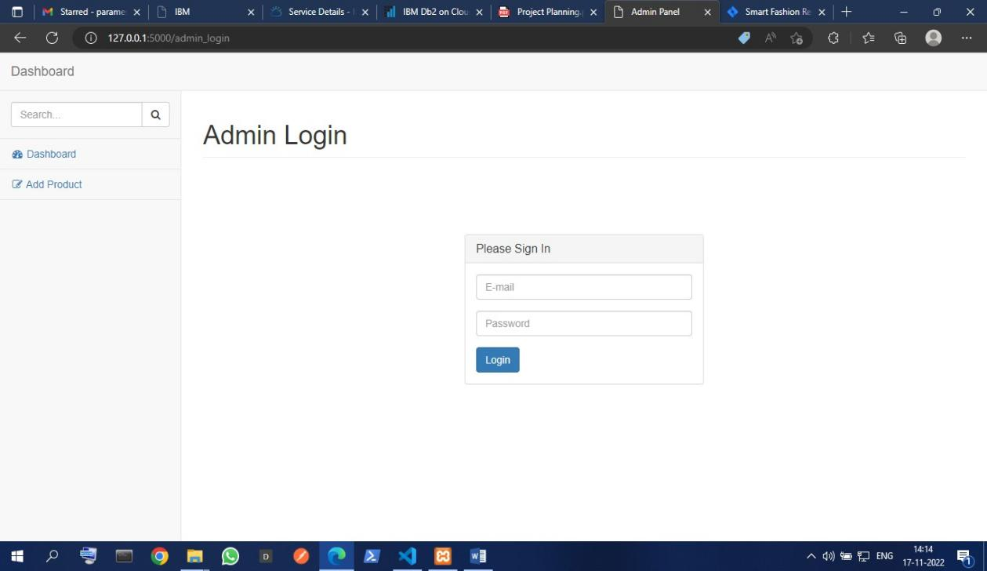

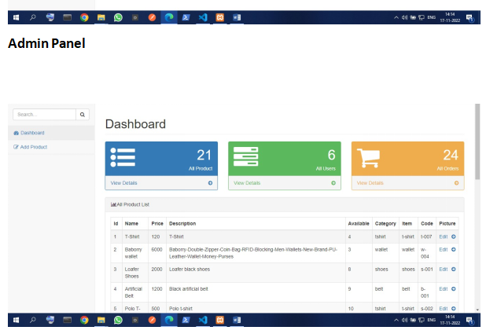

## DATABASE SCHEMA:

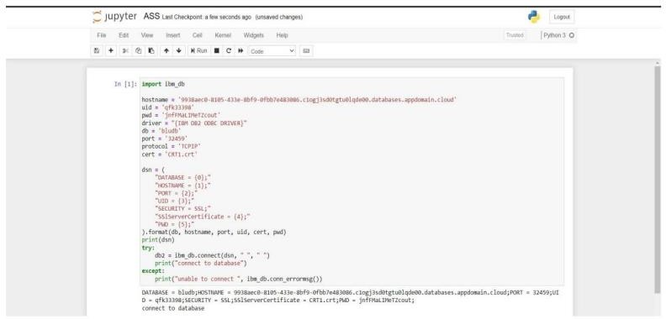

1. **TESTING**
   1. **User Testcase**

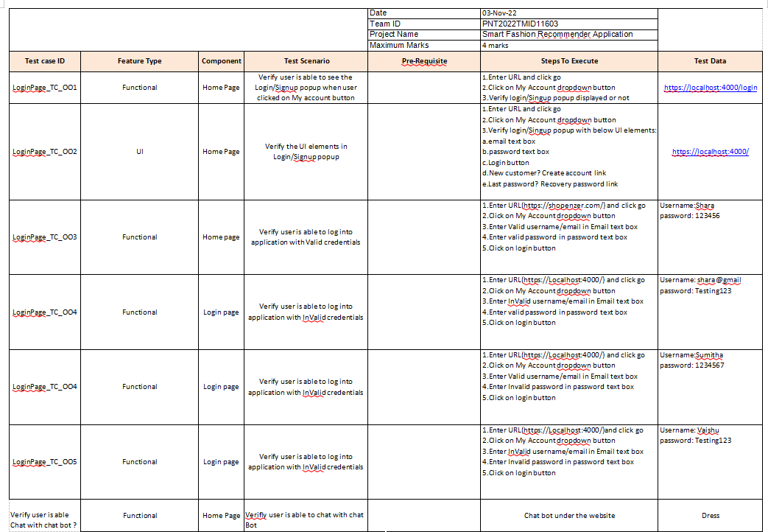ss

## UAT

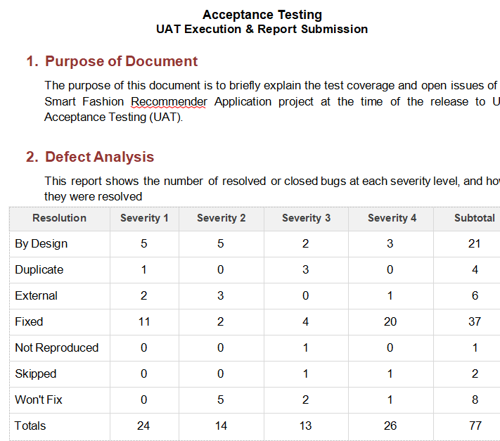

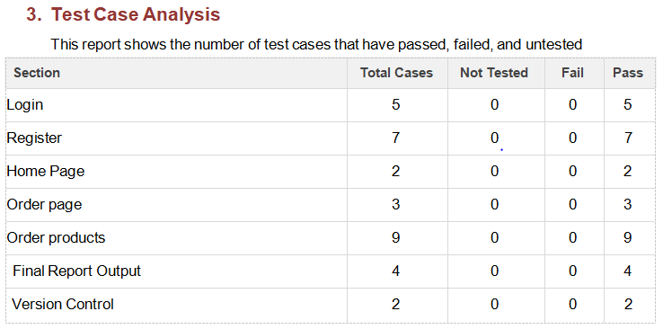

## RESULTS

* 1. PERFORMANCE METRICS:

The performance of a recommendation algorithm is evaluated by using some specific metrics that indicate the accuracy of the system. The type of metric used depends on the type of filtering technique. Root Mean Square Error (RMSE), Receiver Operating Characteristics (ROC), Area Under Cover (AUC), Precision, Recall and F1 score is generally used to evaluate the performance or accuracy of the recommendation algorithms.

*Root-mean square error (RMSE)*. RMSE is widely used in evaluating and comparing the performance of a recommendation system model compared to other models. A lower RMSE value indicates higher performance by the recommendation model. RMSE, as mentioned by [[61]](https://encyclopedia.pub/entry/13081" \l "ref_61), can be as represented as follows:



where, *Np* is the total number of predictions, *pui* is the predicted rating that a user *u* will select an item *i* and *rui* is the real rating.

*Precision*. Precision can be defined as the fraction of correct recommendations or predictions (known as True Positive) to the total number of recommendations provided, which can be as represented as follows:



It is also defined as the ratio of the number of relevant recommended items to the number of recommended items expressed as percentages.

*Recall*. Recall can be defined as the fraction of correct recommendations or predictions (known as True Positive) to the total number of correct relevant recommendations provided, which can be as represented as follows:



It is also defined as the ratio of the number of relevant recommended items to the total number of relevant items expressed as percentages.

*F1 Score*. F1 score is an indicator of the accuracy of the model and ranges from 0 to 1, where a value close to 1 represents higher recommendation or prediction accuracy. It represents precision and recall as a single metric and can be as represented as follows:



*Coverage*. Coverage is used to measure the percentage of items which are recommended by the algorithm among all of the items.

*Accuracy*. Accuracy can be defined as the ratio of the number of total correct recommendations to the total recommendations provided, which can be as represented as follows:

## ADVANTAGES & DISADVANTAGES

**ADVANTAGES:**

* + - Smart fashion recommender application is the user friendly.
    - With the help of chatbot user cand find the products very easily.
    - This application used to discover the product based on the user’s choice , very easily and quickly.
    - It have ability to reduce transaction costs for consumers,and increase revenue for retailers.

## DISADVANTAGES:

* + - * It need active internet connection.
      * Privacy concerns.
      * Too many choices.
      * Cold-start problem.

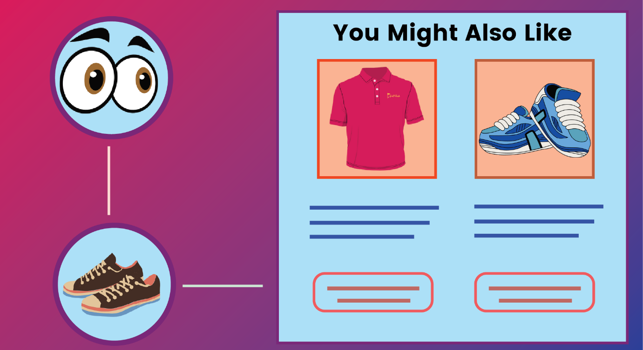

# CONCLUSION

The Fashion Recommendation System is mainly used to recommend the best possible outfit combinations to a user who has no fashion sense based on their wardrobe . It may not always provide the best possible outfit to wear for an occasion as the system is dependent completely on the clothes present in the user’s wardrobe. Also another reason is that fashion is highly dependent on the time period. However the system does a great job in inculcating a fashion sense among the users and can provide the best recommendations based on the user’s wardrobe. Since the system is implemented as a website, it is very easy for the end users to access as well as use. The scope of this system can be expanded by including the ability to detect the various design and patterns on clothing, and to increase the number of occasions.

# FUTURE SCOPE

In the future, to implement this recommendation system to be extended to include male and non-binary fashion items including apparel, footwear, accessories etc. This work can further be enhanced to predict fashion items based on the skin colour and weather conditions.

Future research should concentrate on including time series analysis and accurate categorization of product images based on the variation in colour, trend and clothing style in order to develop an effective recommendation system. The proposed model will follow brand-specific personalization campaigns and hence it will ensure highly curated and tailored. offerings for users. Hence, this research will be highly beneficial for researchers interested in using augmented and virtual reality features to develop recommendation systems.

## APPENDIX

**SOURCE CODE: LOGIN:**

<html>

<head>

<meta name="viewpoint" content="width=device-width, initial-scale=1.0">

<title>FASHION FREAK</title>

<link rel="stylesheet" href="https://storagedemo-madzh.s3.jp-tok.cloud-object- storage.appdomain.cloud/Regcss.css">

</head>

<body>

<div class="main">

<div class="navbar">

<div class="menu">

<ul>

</ul>

</div>

</div>

<div class="content">

<h1> SMART FASHION <br><span>APPLICATION</span></h1>

<div class="form">

<h2>FASHIONZZ LOGIN</h2>

<form action="/Login" method="post">

<input type="text" name="username" placeholder="ENTER USERNAME">

<input type="password" name="password" placeholder="ENTER PASSWORD">

<button type="SUBMIT" class="btnn"><a href="#">LOGIN</a></button>

<p class="link">DON'T HAVE AN ACCOUNT<br>

<a href="/Register">SIGN UP </a> HERE </a></p>

</form>

</div>

</div>

</div>

</body>

</html>